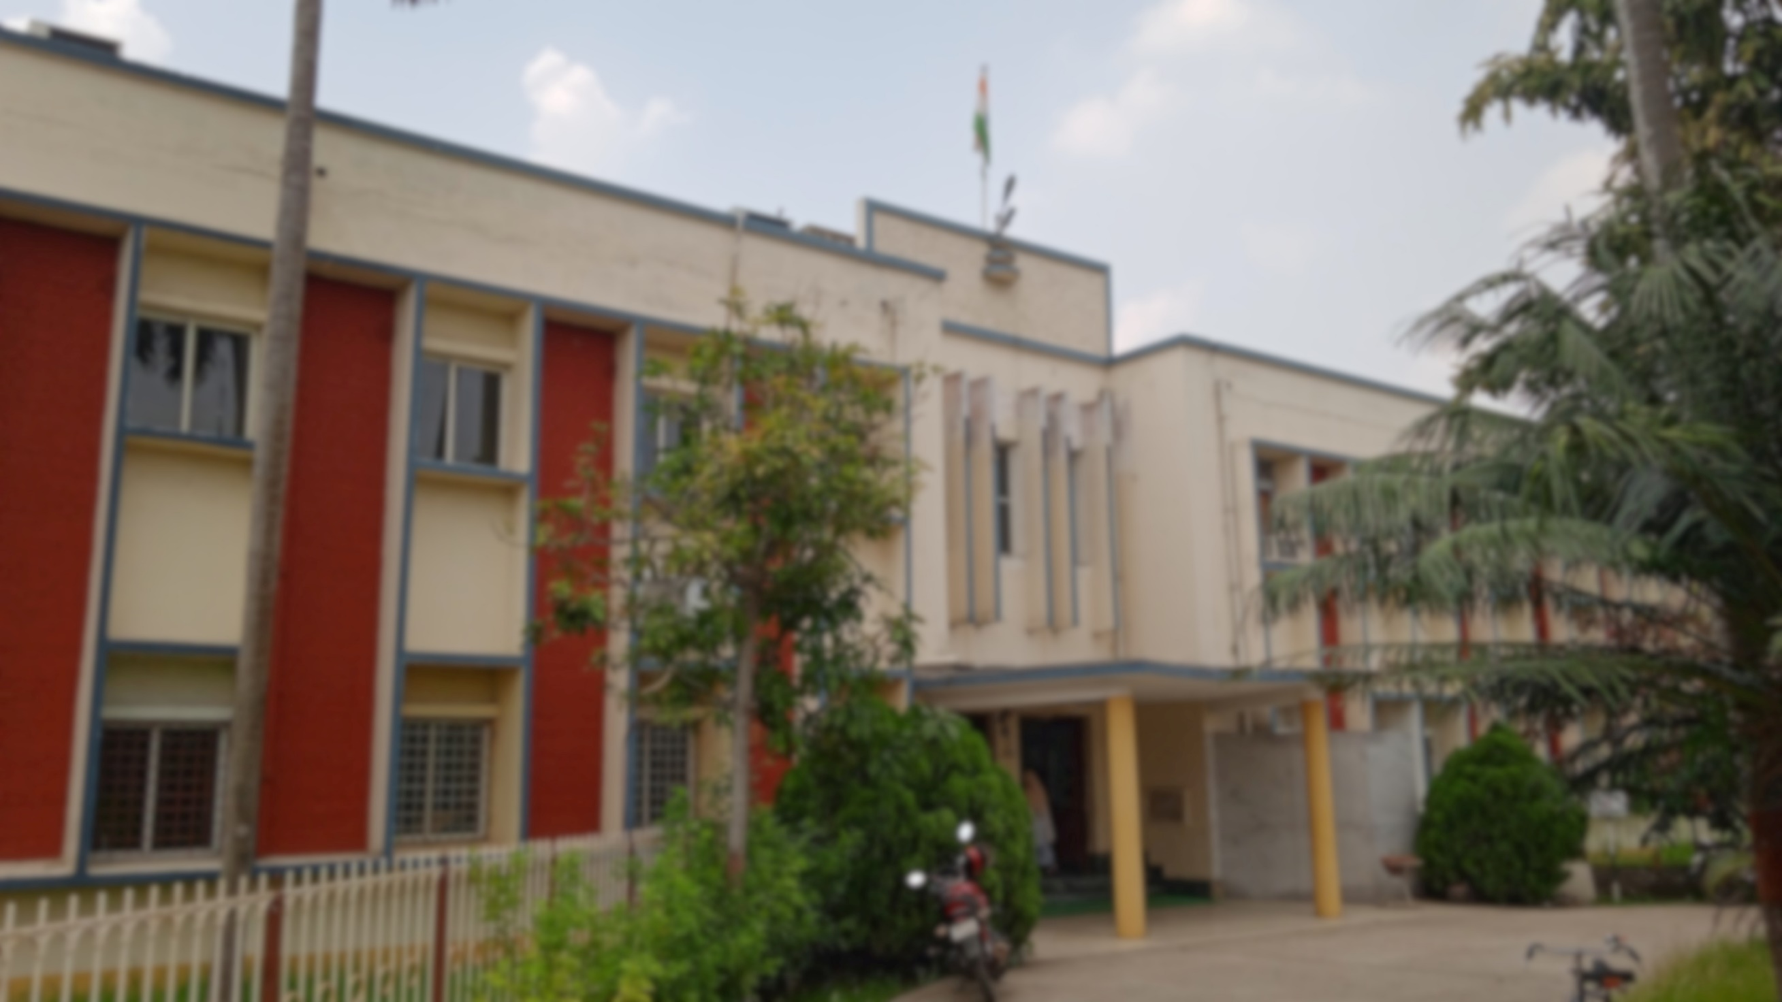

GHAZI KHATIB IMAM

MD. EHTESHAM JAHANGIR

AMAN AHMED SIDDIQUI

MD. IZHAR KHAN

WASIQAH NEYAZ

ALIUL SK

SANJAY SIR

OUR SOLAR TEAM AT NSIC